DAY 1:-

1. **"Given a string s containing just the characters '(', ')', '{', '}', '[' and**

**']', determine if the input string is valid using Stack.**

**An input string is valid if:**

**I.Open brackets must be closed by the same type of brackets.**

**II.Open brackets must be closed in the correct order.**

**III.Every close bracket has a corresponding open bracket of the same type.**

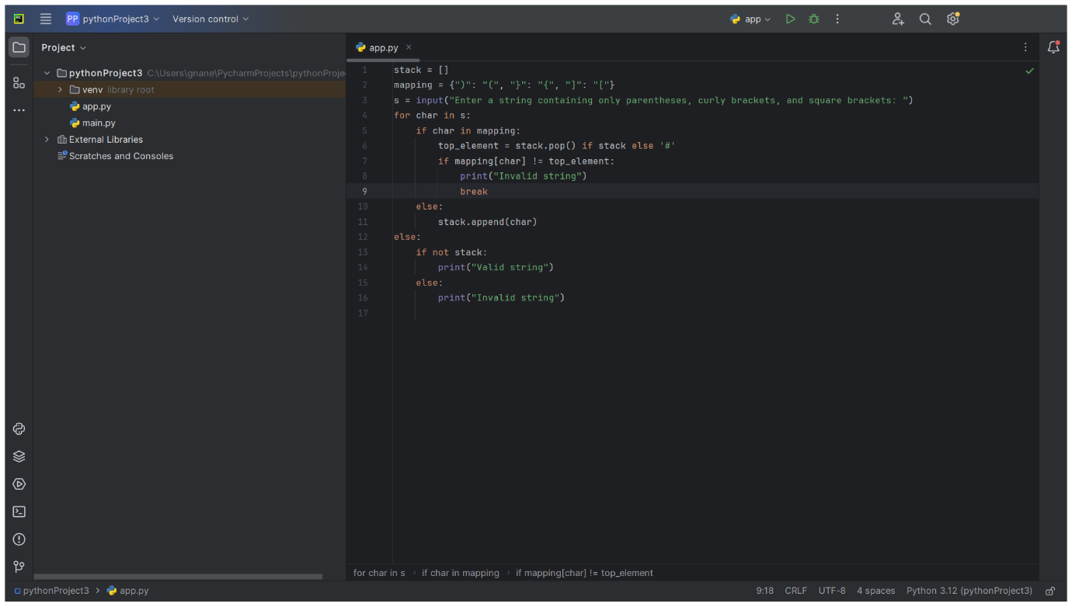

2. **Find the year of the given Anniversary is leap year or not. If leap year then print the**

**next Anniversary, if not leap year then print the previous Anniversary.**

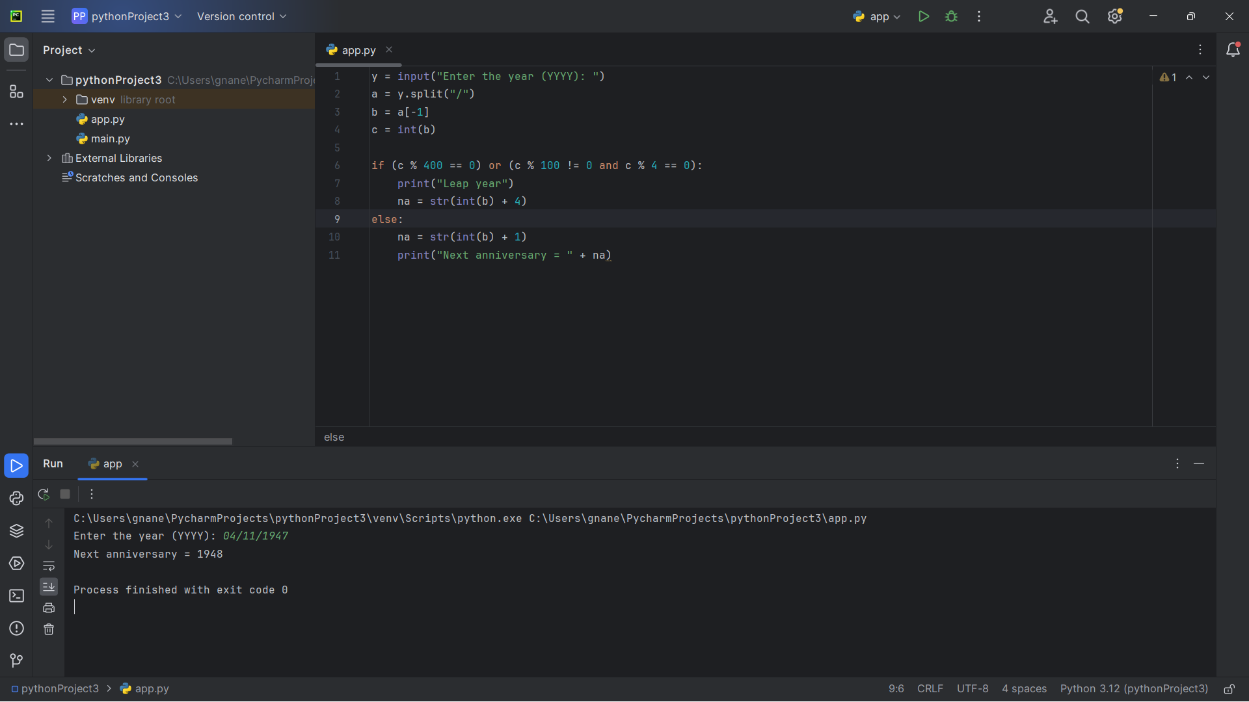

3. **Write a program to print all the Non-Prime numbers between A and B?**

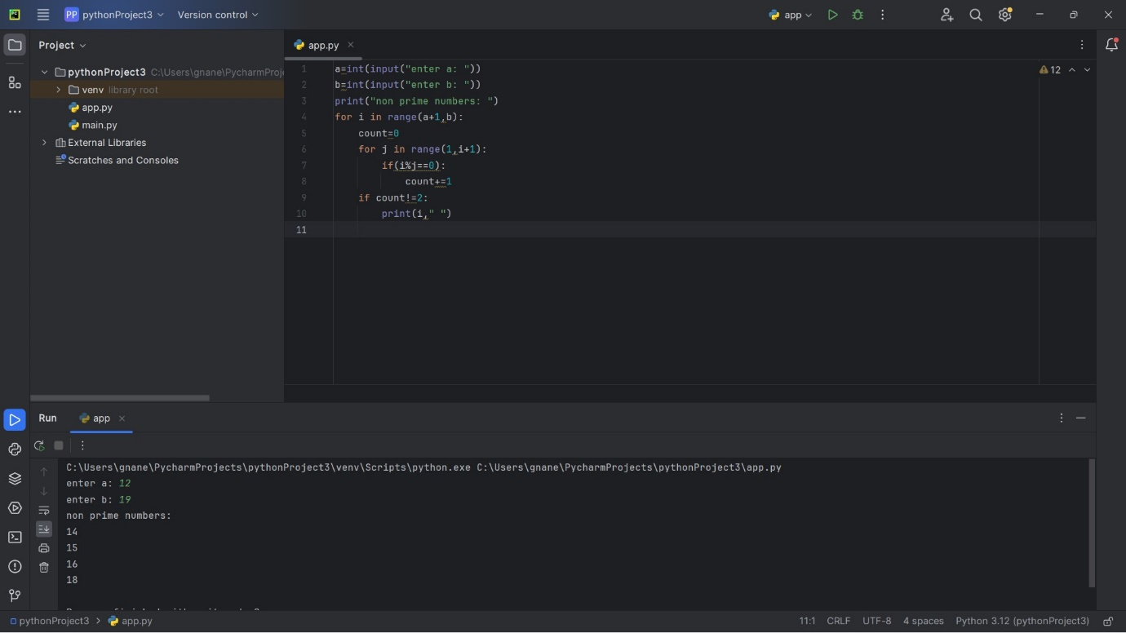

4. **Print the pattern**

**1**

**1 2**

**1 2 3**

**1 2 3 4**

**1 2 3 4 5**

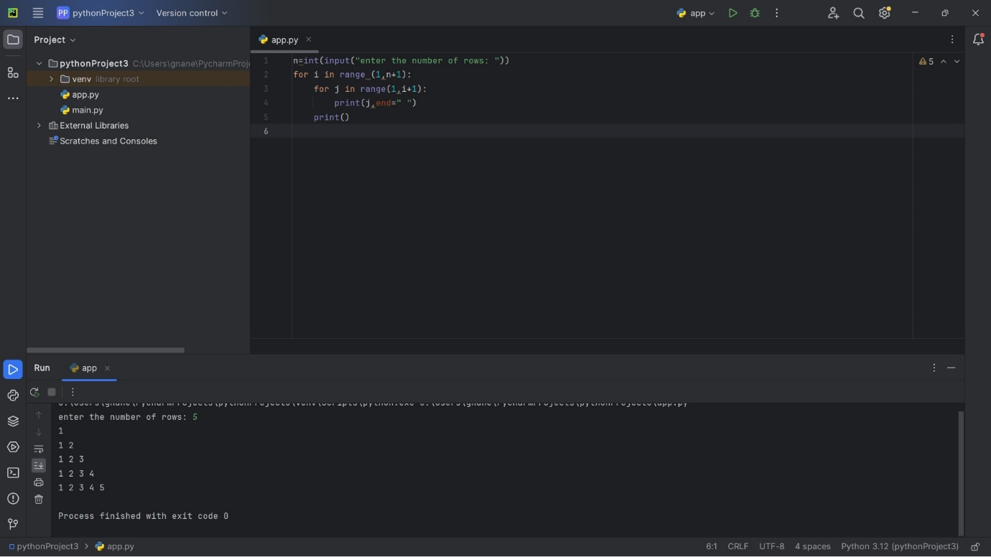

5. **Write a program to print the total amount available in the ATM machine with the conditions applied.**

**Total denominations are 2000, 500, 200, 100, get the denomination priority from the user and the total number of notes from the user to display the total available balance to the user**

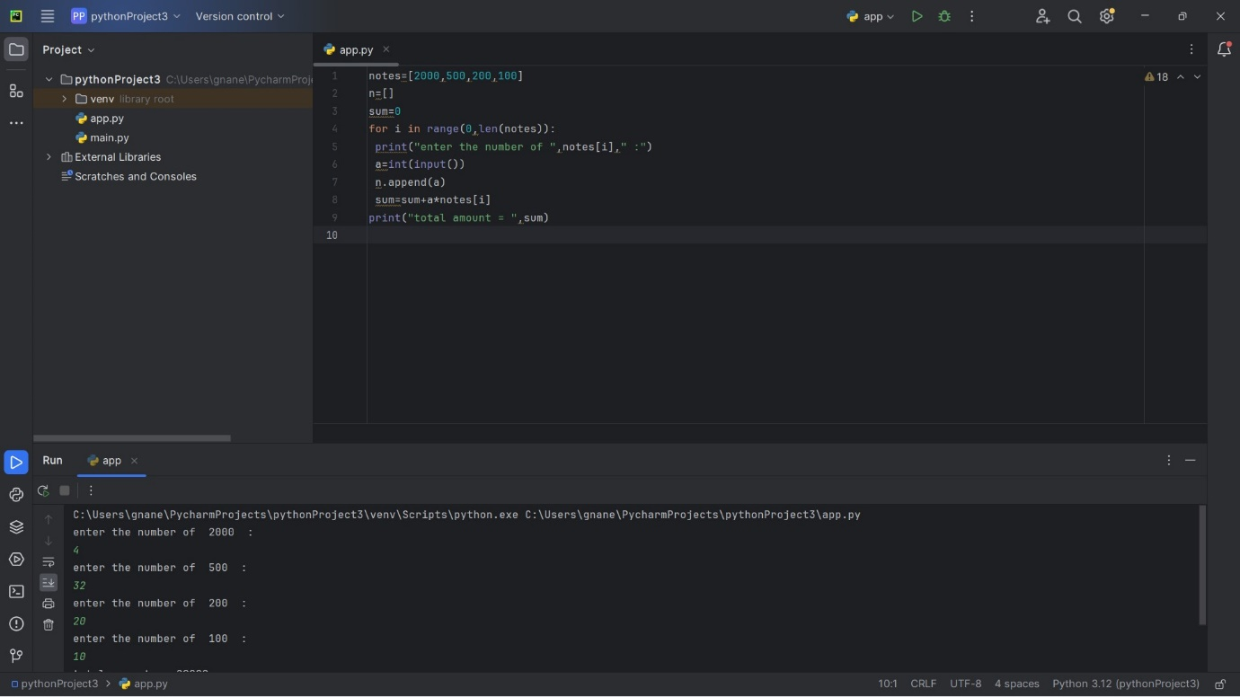

6. **Write a Python program to find the maximum of three numbers entered by the user.**

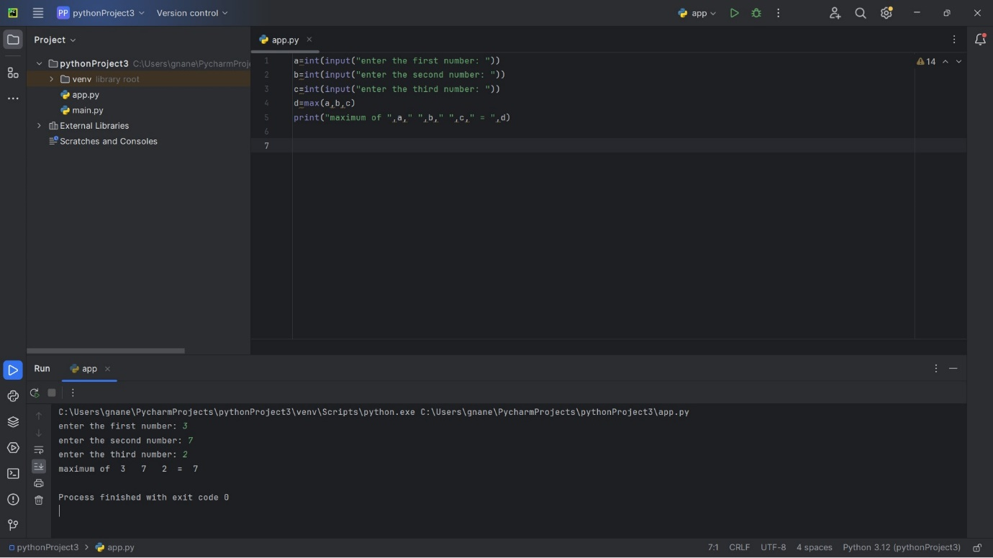

7. **"Write a Python program to find the Nth Fibonacci number. The program should take the value of N as input where n=8**

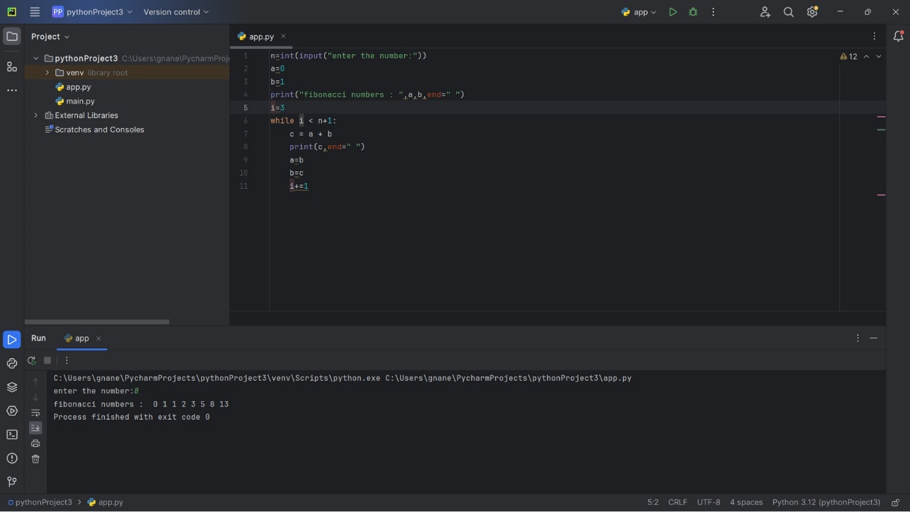

8. **Write a Python program to create a basic calculator that can perform addition, subtraction, multiplication, and division using functions.**

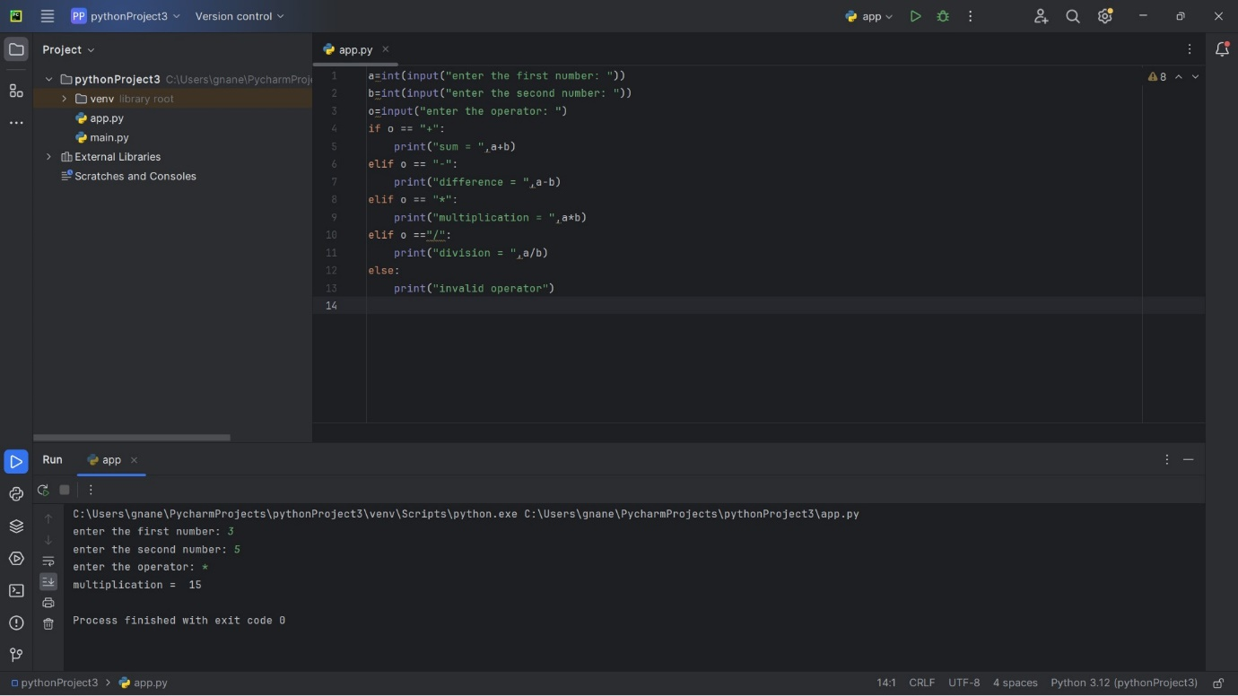

9. **Write a program to find whether the person is eligible for vote or not. And if that**

**particular person is not eligible, then print how many years are left to be eligible.**

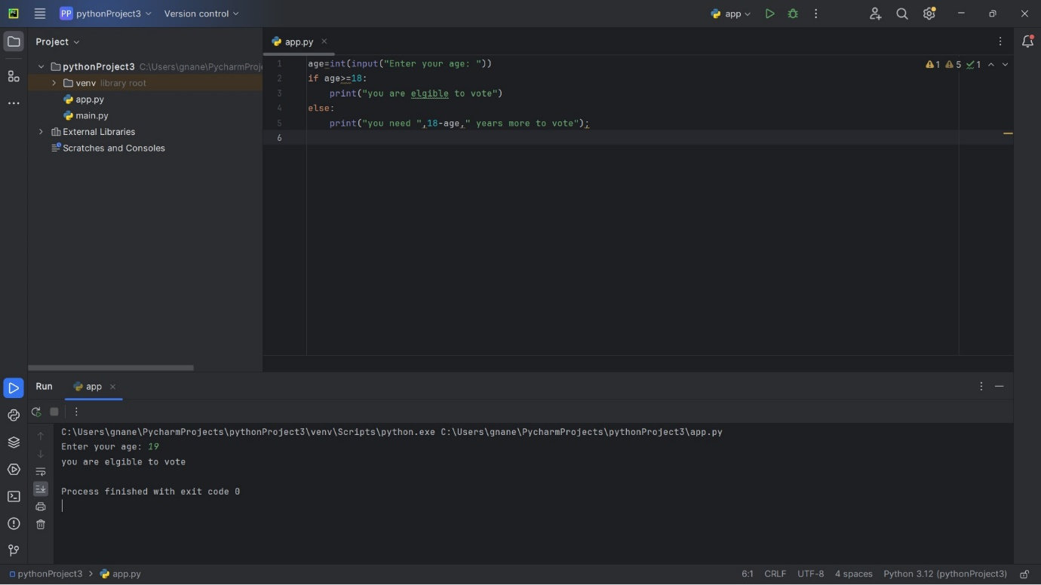

10. **Write a program to reverse a word using loop?(Not to use inbuilt functions)**

